## Home Work Task:

Use all practices from “Java Script. Core and best practices” presentation.

What you may to use:

- Native (clear) JS or jQuery for DOM manipulations and controls state;

Code should be:

1. In separate file;
2. Call things by their name — easy, short and readable variable and function names;
3. Stick to a strict coding style/Optimize loops;
4. Write code comments;

## Tasks:

1) Use plugin sortable for tab boxes implementation:

<http://isotope.metafizzy.co/>

Requirements:

* User should to be able look all boxes and filtered them by rules.

- Please don’t forget for slider transition inside the particular tab box;

Look for video tabs-sotope.mov – in the materials folder. (1 point)

2) Please implement functionality to create new item for skills box (2 points):

* Implement validation:

1. Name for skill - length should not be more than 100 characters

2. Skill range should be not more that 100 point!

## Macintosh HD:Users:andriigordiichuk:Desktop:Screen Shot 2016-01-18 at 9.11.33 PM.png

3) Please create link navigation when user click on items links – page should scrolling for particular container. – “anchor navigation” – the active state on the <li> element show that user currently stay on particular container. (2 points)

4) Create “go to top” functionality. When user clicks on the “btn-top”. (1 point)

## Macintosh HD:Users:andriigordiichuk:Desktop:Screen Shot 2016-01-18 at 9.19.58 PM.png

6) Please implement functionality for “open-close” sidebar – when user press on the toggle burger button. (1 point)

7) Please create loading history post for history box (3 points);

As User I would be able to scrolling block with history and load data from Database, parse it and create new education list DOM node.

Use:

<https://www.firebase.com/>

- to create your user data base;

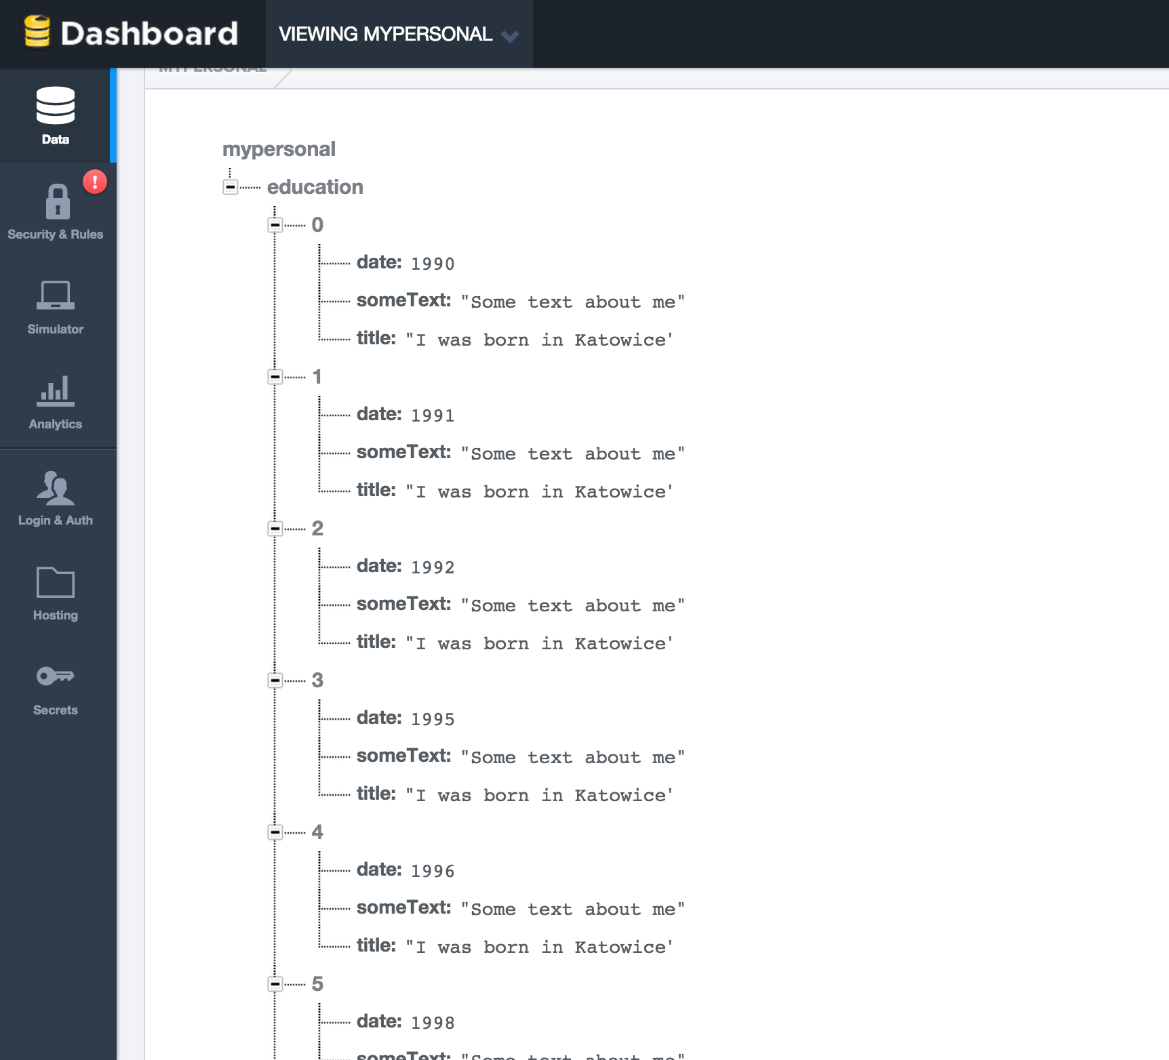

* Create JSON file something like this and imported it to your base;

{

"education": [

{

"date": 1990,

"title": "I was born in Katowice",

"someText":"Some text about me"

},

{

"date": 1991,

"title": "I was born in Katowice",

"someText":"Some text about me"

},

{

"date": 1992,

"title": "I was born in Katowice",

"someText":"Some text about me"

},

{

"date": 1995,

"title": "I was born in Katowice",

"someText":"Some text about me"

},

{

"date": 1996,

"title": "I was born in Katowice",

"someText":"Some text about me"

},

{

"date": 1998,

"title": "I was born in Katowice",

"someText":"Some text about me"

}

]

}

Please use Firebase JavaScriot API to load data by limiting chunks ;

<https://www.firebase.com/docs/web/api/>

Cases:

* When user scroll box to the bottom – send query to Firebase and get first 5 Object;
* Than create 5 items and upload them to the “Education” list;

Please look fire-base-loading.mov from materials folder;